Name: Afsana Rimi

ID: 16-32150-2

VIRTUAL REALITY SYSTEMS DESIGN [A]

Title

**Nouka Baich**

High Concept

Nouka Baich is a traditional dragon boat-style rowing sport of Bangladesh. It’s a racing game, which can be played with multiple online opponents and also can be played via offline AI opponents. The game scenario will be a rural area of Bangladesh and Nouka (the native boat of Bangladesh). A Bangladeshi player who comes to change his life by winning Nouka Baich race. Winning will help him to get relief from poverty else loosing will result in suffering death for starvation. By Winning the Nouka Baich race Majhi can change his life, become famous and continue his boat racing journey.

The game can be played both online and offline. The game would have social media integration so that other friends can see social media friends score and comparison with his. There will be a login module + create an account module. And also, the player can exit from the main menu.

Also, the in-game store will be provided with exciting content for the player. The player can buy from character to boat, optimizing boat component and much more.

Game Over will occur only when the player boat reaches critical damage or player himself gain critical damage during playing.

This game would support a wide range of devices to support a big consumer base. Also, there will be VR mode. Alongside VR mode there will be non VR mode of the game, so that players who don’t have VR devices to play can play and enjoy the game. For a long time playing, VR is not that much sweet able option to adopt.

Pitch

* Player motivation

In This Game, the player is trying to win in the game of a nouka baich (boat racing) tournament. Players' role is to finish a certain part before other players can finish. There will be various kinds of obstacles and different river scenario based on the level of the game. Also, there will be a dynamic obstacle that will be activated based on the custom difficulty of the game. After passing every level player will be able to win in-game gifts and coins. Also, the player can set a level of difficulty to easy, normal, hard and extreme hard.

* Genre: Arcade

The Genre Of this game is Arcade. Arcade a type of game genre that is a fast-paced action game (for PC or console), requiring hand-eye coordination skills to play.

* License

License Type: In-licensing. The Licensor will provide the licensee a game to distribute and/or operate. The licensor will develop the game according to the license agreement.

* Target customer

Target Customers are from age 3+, both male and female, from kid to adult. There is no bad word or sexual content, or religious belief or country involved in the game design. In brief, everyone who is eligible to play the game is welcomed to play our game.

* Competition

There is no game like this one, but in this game, we focused on the natural enjoyable gaming environment which will be a new experience for any game player, although the game will not be a horror/fight type game, it will be built for every age of customers.

* Unique selling points

The new feature of the game will be Facebook, twitter, google integration, the player can play with his/her real Facebook friend in the real-time. Also, an in-game chat option will only be available for the player aged 13+.

Anonymous player mate finder option for age 21+ with age verification, and in chat option there will be an AI-generated protection system, people who do bullying or sexual harassment will be banned automatically. Also, there will be custom complain and blocking system in the app for anonymous gaming.

* Target hardware

Android Phone, iPhone, Windows PC/ MAC device. Gyroscope sensors will be used in all mobile handheld devices, for without gyroscope phones, the game can be played via arrow keys. The device which has no keyboard nor gyroscope will be able to play the game via touch. Additionally, VR headset needed for this game. Also can be played without VR.

* Design goals

There will be pounding excitement in every second of the gameplay. There will be tension and suspense. Additionally, in the multiplayer option, there will be Strategic challenges and Humor. Moreover, there will be a heartwarming story of Nouka Baich and our cultural activity.

Concept

* Explanation of the game's genre

This game’s genre type will be **Arcade**. Arcade games can consist more than one type of Subgenre. Arcade Genre mean player must keep concentrate every moment while gaming.

This arcade game will also consist of another Subgenre such as,

Sub-Genre: **Graphic adventure** games emerged as graphics became more common. Adventure games began to supplement and later on replace textual descriptions with visuals.

Sub-Genre: **Vehicle simulation** games are a genre of video games which attempt to provide the player with a realistic interpretation of operating vehicles (Boat). Sub-Genre: **Racing games** typically place the player in the driver's seat of a vehicle and require the player to race against other Boat drivers or sometimes just against fixed time.

* Gaming platform

This game will be developed in Unity 3D game development engine. Can be played with Android Phone, iPhone, Windows PC/ MAC device. Gyroscope sensors will be used in all mobile handheld devices. Although game can be played VR and non VR mode to support every level of customer.

* Category

This project will be mobile/PC/MAC VR type application including feature of playing without VR headset.

* Game's Premise

The Premise: A Bangladeshi Majhi who come to change his life by winning Nouka Baich race. Winning will help him to get relief from poverty else loosing will result suffering death for starvation. By Winning the Nouka Baich race Majhi can change his life, become famous and continue his boat racing journey.

* Project's scope and learning objective
* Learn how to drive ancient boat
* Optimize brain response while playing game
* Learn how to perform survive in a rough VR boat race
* Description of the target audience

Target audience are from age 3+, both male and female, from kid to adult. There is no bad word or sexual content, or religious belief or country involved in the game design. In brief, everyone who is eligible to play the game is welcomed to play our game. Only eligibility will be owning compatible hardware.

* Play mechanics and game play description

Gameplay mechanics will be based on how much obstacle can a player avoid during gameplay. Also, how fast player can achieve end spot of the game. Player can play single mode, with pc (bot / AI) mode, and multiplayer mode. Player can hit another player and win by cheating also. Good player must go through every kind of obstacles. Play mechanics will also follow basic physics law (not extreme realistic but realistic). In VR play mode player can see same as boat observer see and feel like real boat driving experience.

* Thematic concepts

Player vs player

Player vs bot

Player vs none (fixed time)

Player vs none (unlimited time, no score , practice play)

* Description of the game's environment

It’s a racing game, which can be played with multiple online opponents and also can be played via offline AI opponents. The game scenario will be a rural area of Bangladesh and Nouka (the native boat of Bangladesh).

* Development of characters

The character of this game will come from a different place of the village. Some will be farmer, some will be fishermen, some will be wood cutter , and many others. Also, girl characters and imaginary food characters will be supported.

Additional Deliverables (appendix)

* Initial game-design document

When a game is commissioned by a publisher, the GDD document must be created by the developer team.

* Narrative treatment and possibly some sketches for gameplay

* Flowcharts for one level of play

* Concept art

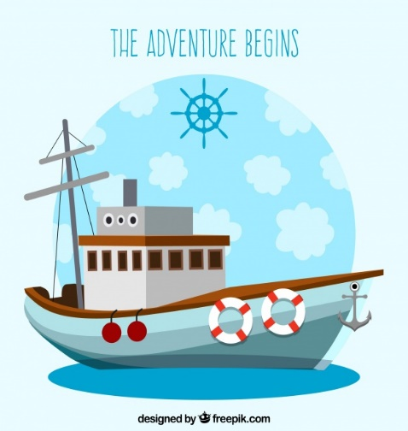

Refferences

1. Draw.io website used for drawing flowchart
2. Picture Taken from Google search result.